
Savitribai Phule Pune University
Interdisciplinary School of Scientific Computing (ISSC)

Mid Semester Exam.- I August 2017

Course No. : SC - 104

Title : Mathematics for Scientific Computing

Date : 17/08/2017
Time : 2:30 pm to 4:00 pm Marks : 30
______________________________________________________________________________

Note : 1) Answers to all subquestions of a question should appear together.
2) Q.1. is compulsory, answer any three of the remaining questions.

Q.1. Solve any six. (2 marks each.)

(i) Plot the graph of f(x) = 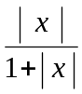 −3 ≤ x ≤ 3 .
lim
h 0
√ x + h − √ x
h
(ii) Evaluate the limit .

(iii) Is the function f(x) = x^{2/3} continuous at x = 0 ? Is it differentiable at
x = 0 ? Justify.
dy
dx

(iv) Calculate from the equation a^{xy} = 1.

(v) Locate and classify critical points of f(x) = x³ −x .
dy
dx

(vi) Find if y = t³ and x = t² + 1 .

(vii) What value of will make given 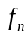 continuous at 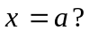

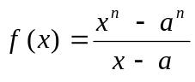 if 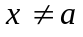
if 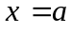
(viii) Show that 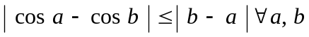

Q.2. For the function f(x) = 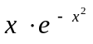

(i) Find the regions in which it is concave up or concave down. (2)

(ii) Find the points of inflection. Locate and classify critical points. (2)

(iii) Sketch the curve for − 2 ≤ x ≤ 2. (2)

Q.3. (a) Find the volume of the largest right circular cylinder that can be inscribed (4)
in the sphere of radius r.

(b) A heavy rock is blasted vertically upwards, with a velocity of 160 ft/s., (2)
reaches height of s(t) = 160t − 16t² feet after t seconds. How high does
the rock go ?

Q.4. (a)Evaluate the following limit by Hospitals Rule. (2)

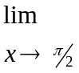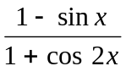
(b) Show that 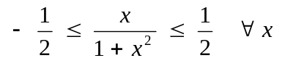 (4)
Let 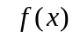 be 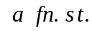
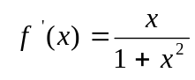
Show that
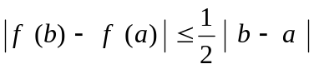 for 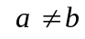
Q.5 (a) The length of a rectangle is decreasing at the rate 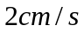 and the width is (3)
increasing at the rate of . At what rate the area and the perimeter of the
rectangle changing when 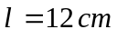 and 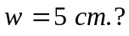

(b) Determine the constants and in order that the function (3)
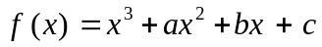 has
(a) a maximum at 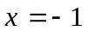and a minimum at 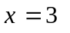
(b) a minimum at 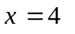and a point of inflection at 



